UPI Fraud Shield Simulator

IT23431- MONGODB ESSENTIALS

Submitted by

HARIHARAN T – 241001070
HARISH RAGHAVA – 241001080
KARTHIK J –241001107

OF

BACHELOR OF INFORMATION TECHNOLOGY



RAJALAKSHMI ENGINEERING COLLEGE, THANDALAM

(An Autonomous Institution)

RAJALAKSHMI ENGINEERING COLLEGE

BONAFIDE CERTIFICATE

Certified that this project titled “UPI Fraud Shield Simulator” is the Bonafide work of “HARIHARAN T(241001070), HARISH RAGHAVA(241001080),KARTHIK J(241001107)” who carried out the project work under my supervision.

SIGNATURE

Dr.Valarmathie
HEAD OF THE DEPARTMENT
Information Technology
SIGNATURE

Dr.Usha S
Associate Professor
Information Technology

This project is submitted for IT23431- MONGODB ESSENTIALS held on

INTERNAL EXAMINAR EXTERNAL EXAMINAR

ACKNOWLEDGEMENT

First, we thank the almighty God for the successful completion of the project. Our sincere thanks to our chairman Mr.S. Meganathan, B.E., F.I.E for his sincere endeavour in educating us in his premier institution. We would like to express our deep gratitude to our beloved Chairperson Dr. Thangam Meganathan M.E., Ph.D.,, for her enthusiastic motivation which inspired us a lot in completing this project and Vice-Chairman Mr. Abhay Shankar Meganathan B.E., M.S., for providing us with the requisite infrastructure.

We also express our sincere gratitude to our college principal, Dr.S.N.Murugesan M.E., Ph.D., for his kind support and facilities to complete our work on time. We extend heartfelt gratitude to Dr.P.Valarmathie M.E.,Ph.D, Professor and Head of the Department of Information Technology for her guidance and encouragement throughout the work. We are very glad to thank our course faculty Dr. Usha (Associate Professor/IT) of our department for their encouragement and support towards the successful completion of this project.

We extend our thanks to our parents, friends, all faculty members, and supporting staff for their direct and indirect involvement in the successful completion of the project for their encouragement and support.

Hariharan T

Harish Raghava A

Karthik J

TABLE OF CONTENTS

S.NO | TOPIC | PAGE NO
1 | Abstract | 1
2 | Introduction | 1
3 | Purpose | 1
4 | Scope of the project | 2
5 | Software requirement specification | 2
6 | Use case diagram | 3
7 | Entity relationship diagram | 4
8 | Data flow diagram | 5
9 | Module description | 5
10 | Project functionality | 5
11 | Implementation | 6
12 | Conclusion | 8

UPI Fraud Shield Simulator

1.ABSTRACT
The UPI-based Payment Application with AI Fraud Detection is a web-based system for secure digital transactions. It allows users to send and receive money, manage balances, and view transaction history. The system uses Node.js, Express.js, and MongoDB. It also includes fraud detection to identify suspicious transactions and improve security

INTRODUCTION

UPI enables fast digital payments, but it also increases fraud risks. This system provides a secure platform for transactions with basic fraud detection to monitor suspicious activities. It ensures safe and efficient digital payments.

PURPOSE

• To develop a UPI-based payment system
• To enable secure money transactions
• To store transaction data
• To detect fraudulent activities
• To improve payment security

SCOPE OF THE PROJECT

• User registration and login
• Link bank account and manage balance
• Send and receive money using UPI
• View transaction history
• Detect and alert suspicious transactions

SOFTWARE REQUIREMENT SPECIFICATION
Functional Requirements:
• User authentication
• Send and receive payments
• View transaction history
• Fraud detection
Non-Functional Requirements:
• Scalable
• Reliable
• User-friendly
Hardware Requirements:
  - 4GB RAM system Software Requirements:
  - HTML, CSS, JavaScript
  - Python,Flask
  - MongoDB

6.USE CASE DIAGRAM

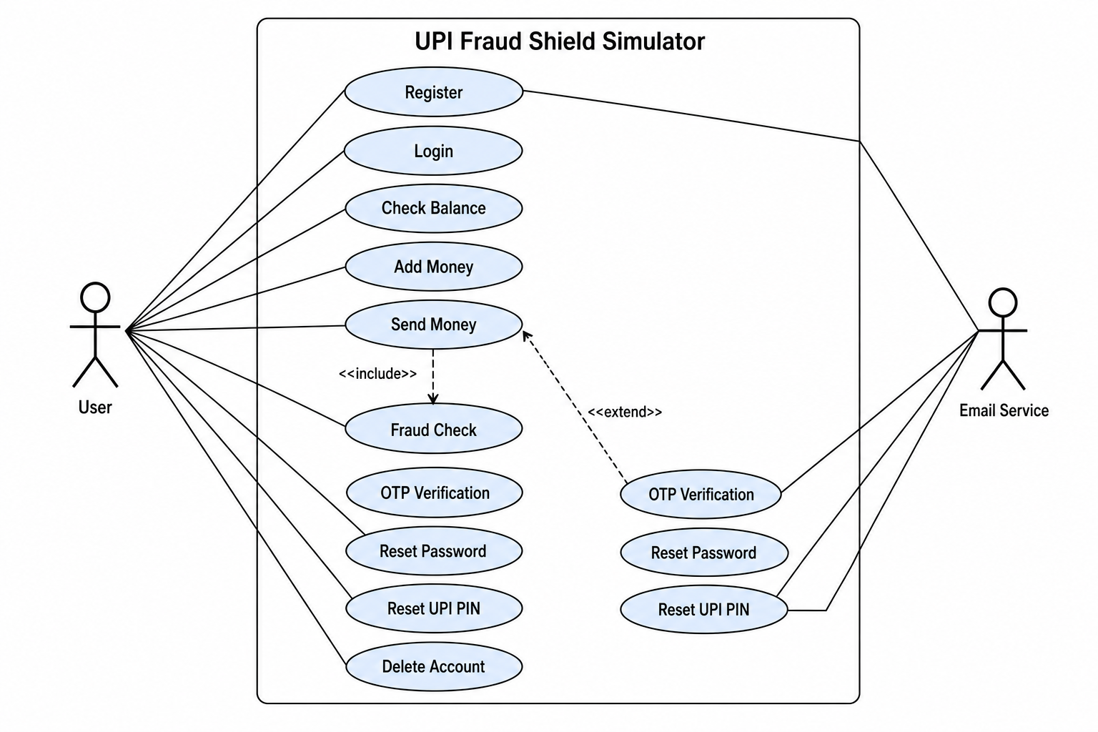
7.ENTITY RELATIONSHIP DIAGRAM

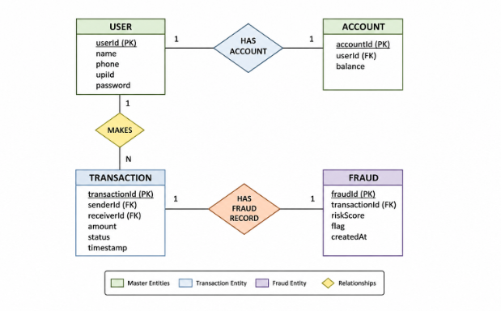

8.DATA FLOW DIAGRAM

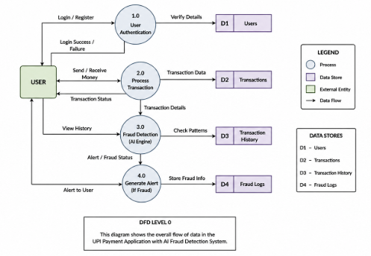

MODULE DESCRIPTION

- Use Case Module – displays the main user interactions with the UPI Fraud Shield Simulator.
- Transaction Module – handles balance check, add money, and send money operations.
- Security Module – manages fraud detection, OTP verification, and safe transaction flow.
- Account Module – supports registration, login, password reset, UPI PIN reset, and account deletion.

PROJECT FUNCTIONALITY
  - User registration and login
  - Link Bank Account
11.IMPLEMENTATION
Three-tier architecture:
Frontend – HTML, CSS, JS Backend – Python,Flask

LOGIN PAGE:

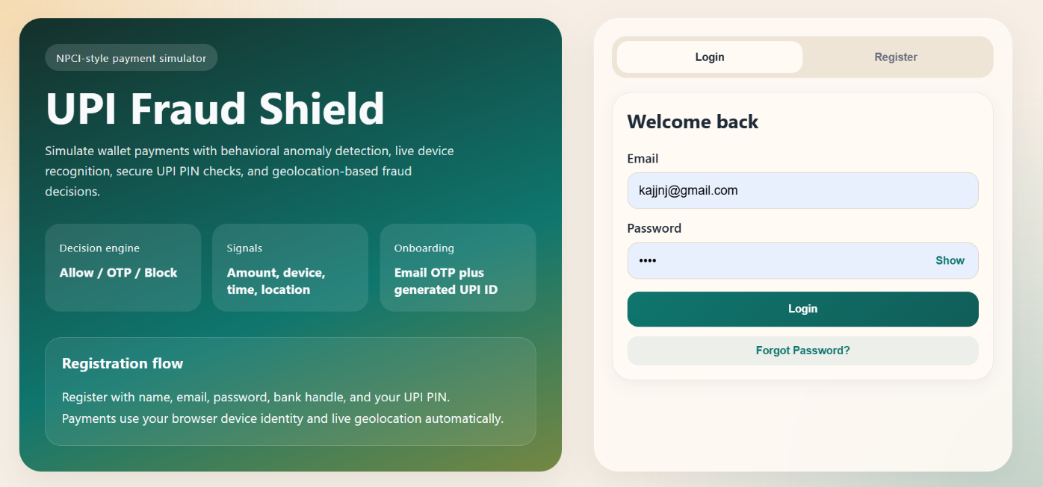

BALANCE IMAGE:

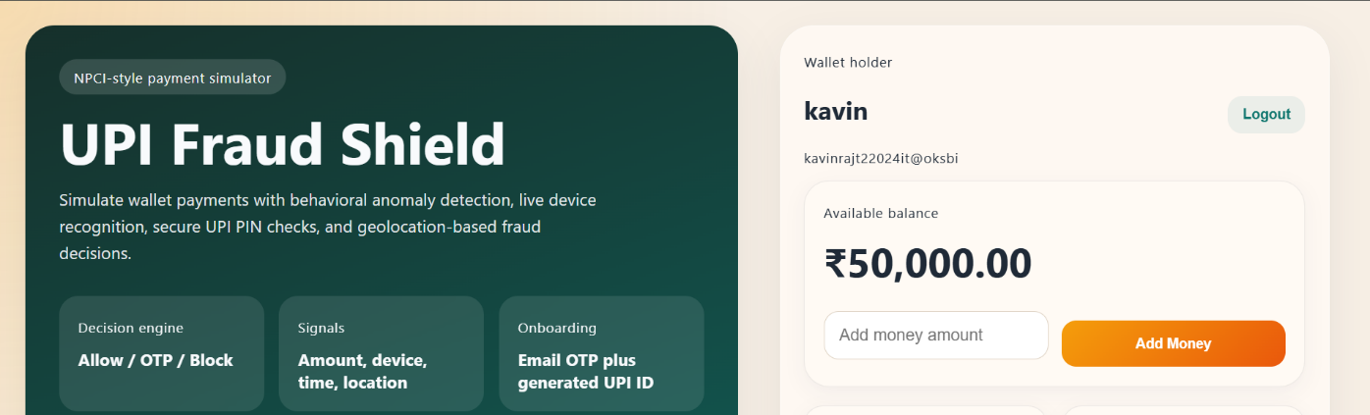

PAYMENT PAGE:
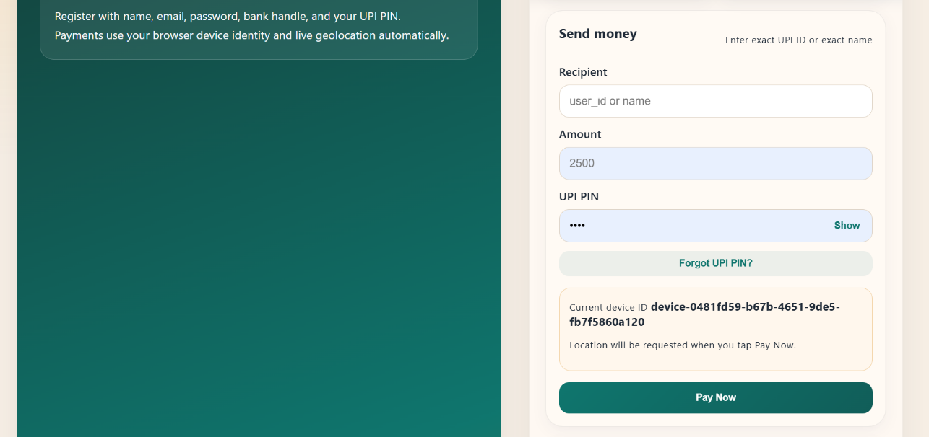

ANALYSIS PAGE:

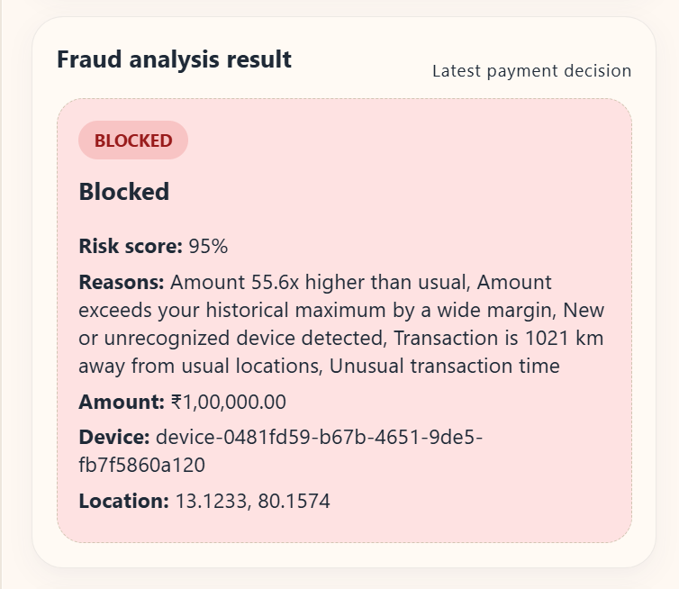

12.CONCLUSION

The system improves efficiency, reduces errors, and demonstrates modern web development with MongoDB.

REFERENCE

MongoDB Docs MDN
W3Schools

